EXPT NO: 5 | IMPLEMENTATION OF A RECURRENT NEURAL NETWORK (RNN) FOR TEXT GENERATION
DATE: 17-09-2026

PRE-LAB QUESTIONS

- Explain the purpose of a Recurrent Neural Network (RNN) in processing sequential data.

A Recurrent Neural Network (RNN) is a neural network designed to process sequential or time-dependent data. It maintains information from previous inputs using a hidden state. This allows the network to understand relationships between elements in a sequence. RNNs are commonly used for text, speech, time-series, and other sequential tasks. For text generation, an RNN uses previous words to predict the next word.

- Why is an RNN considered an appropriate model for text generation tasks?

RNNs are suitable for text generation because text is naturally organized as a sequence of words. The hidden state allows the model to remember information from previously processed words. The model learns patterns and dependencies between words during training. It can then use a given seed word or sentence to predict subsequent words. Therefore, RNNs can generate text that follows learned language patterns.

- Describe the concept of sequence modeling in natural language processing.

Sequence modeling is the process of learning patterns and relationships within ordered language data. In natural language processing, words are processed in a specific order because their meaning depends on context. A sequence model learns how previous words influence the next word in a sentence. RNNs use hidden states to maintain information about earlier parts of the sequence. This makes sequence modeling useful for tasks such as text generation and prediction.

- Explain the importance of tokenization during text preprocessing for RNN-based text generation.

Tokenization divides the input text into smaller units such as individual words. It makes the text easier for the RNN to process as a sequence of tokens. Each unique word can be assigned a specific integer index in the vocabulary. These indices are then used to create numerical input sequences for the model. Thus, tokenization is an important step before training an RNN for text generation.

- Explain the significance of converting text into numerical representations before training an RNN.

Neural networks cannot directly process raw textual words as input. Therefore, words must be converted into numerical representations such as integer indices. These numerical values allow the RNN to process and learn patterns from the text. An embedding layer can further convert the word indices into dense vector representations. This numerical representation enables effective training and next-word prediction.
AIM
To implement a Recurrent Neural Network (RNN) for text generation and evaluate its ability to generate meaningful text by predicting the next word in a sequence.

SOFTWARE REQUIREMENTS
- Python
- TensorFlow or keras or PyTorch
- Google Colab
- GitHub
- Numpy
- Matplotlib

PROCEDURE
TASK A: DATASET PREPARATION
Perform the following tasks:
- Load the Tiny Shakespeare dataset from Hugging Face.
- Explore the dataset and examine the text samples.
- Convert the text into lowercase (if required).
- Tokenize the text into individual words.
- Build a vocabulary and assign a unique integer index to each word.
- Generate input sequences for next-word prediction.
- Apply sequence padding to obtain inputs of equal length.
- Split the prepared sequences into training and validation datasets.

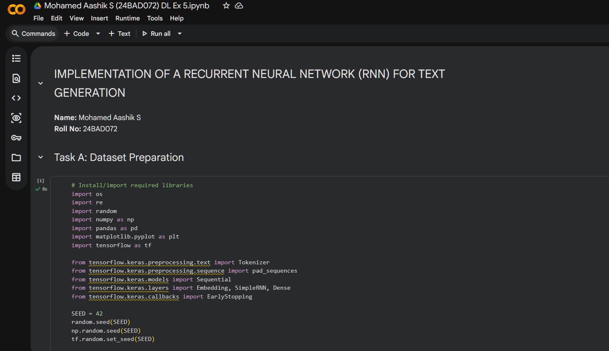
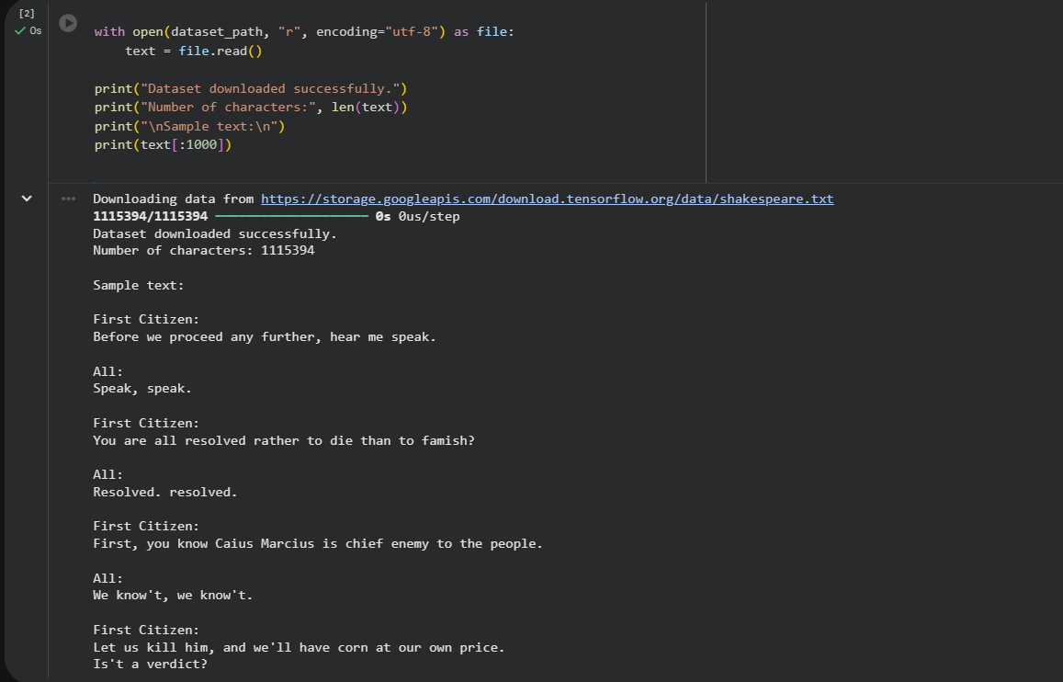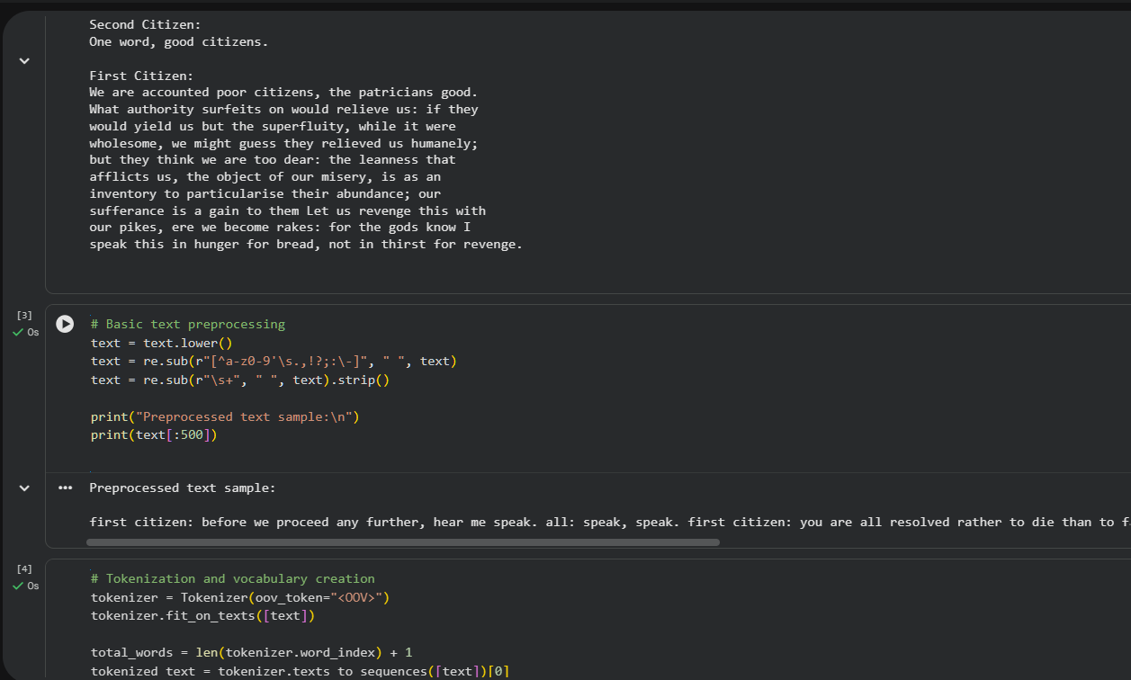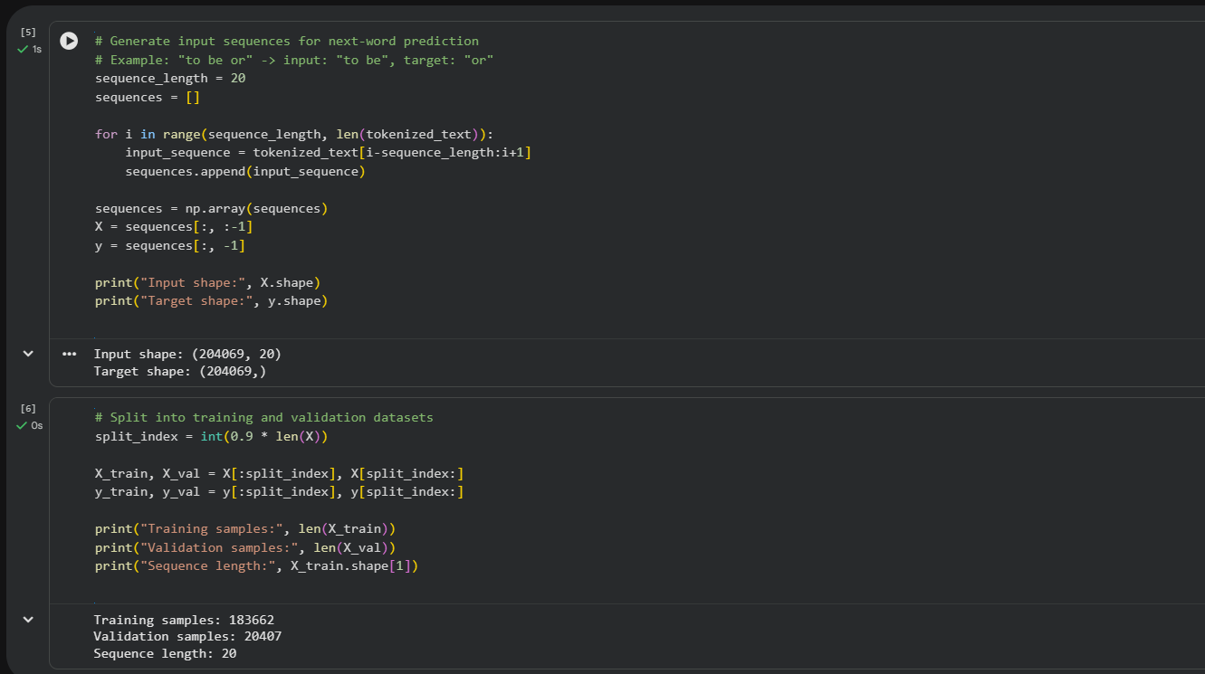

TASK B: IMPLEMENTING THE RNN MODEL
Perform the following tasks:
- Create an Embedding layer to convert words into dense vector representations.
- Add a Simple RNN layer to learn sequential dependencies in the text.
- Add a Dense output layer with Softmax activation for next-word prediction.
- Compile the model using an appropriate optimizer and loss function.
- Display the model architecture and summary.

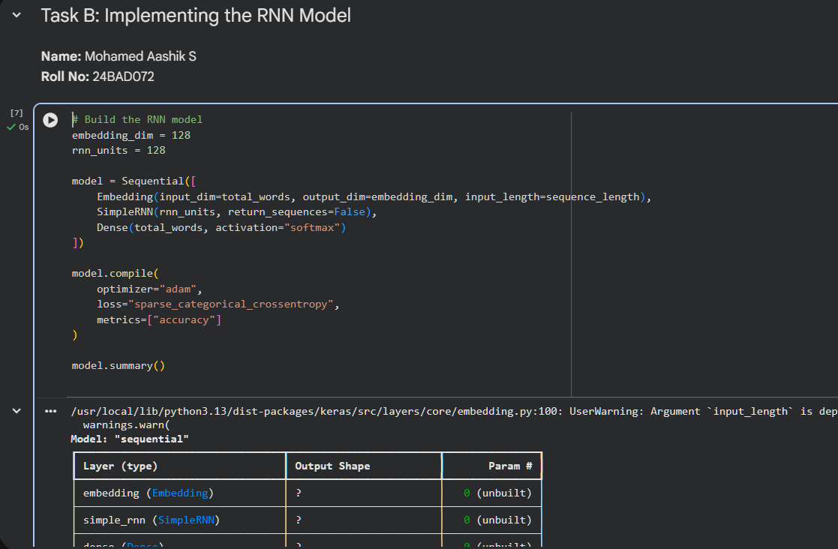

TASK C: RNN MODEL TRAINING AND PERFORMANCE EVALUATION
Perform the following tasks:
- Train the RNN model using the prepared training dataset.
- Validate the model using the validation dataset.
- Record:
  - Training accuracy
  - Validation accuracy
  - Training loss
  - Validation loss
- Visualize:
  - Accuracy vs. Epoch
  - Loss vs. Epoch

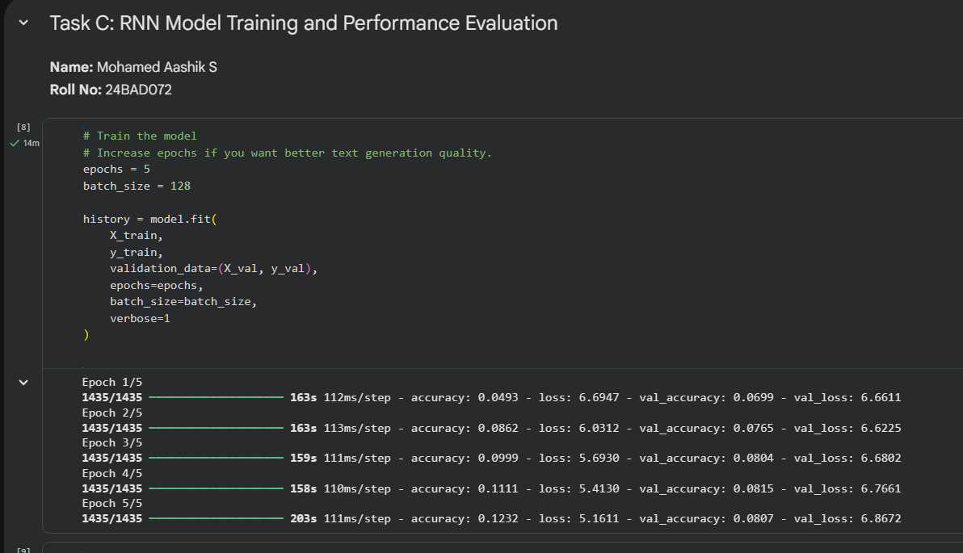
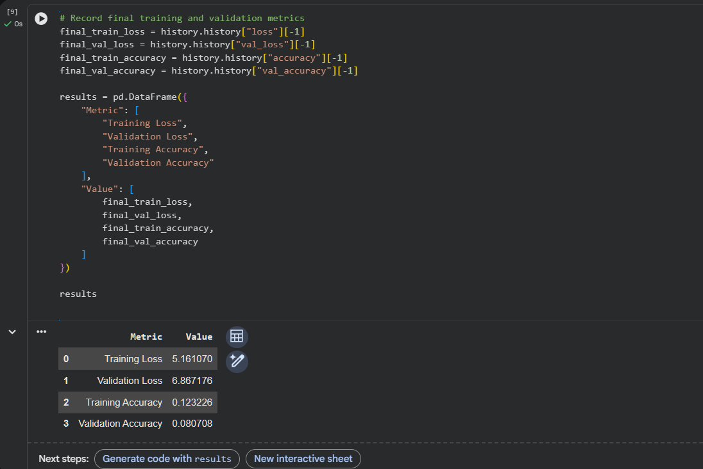
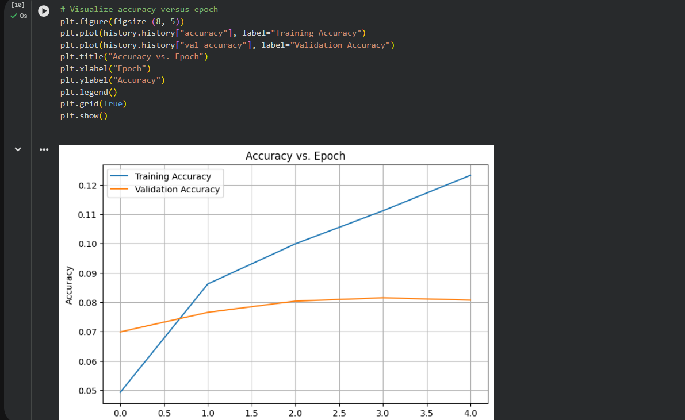
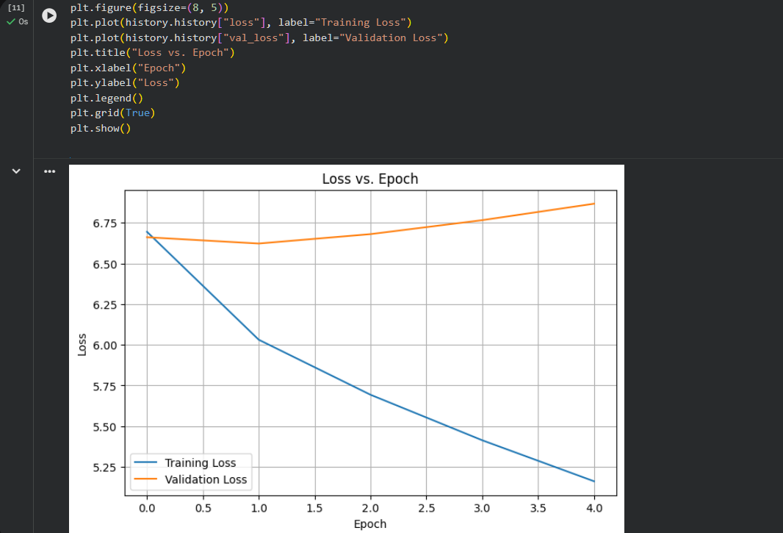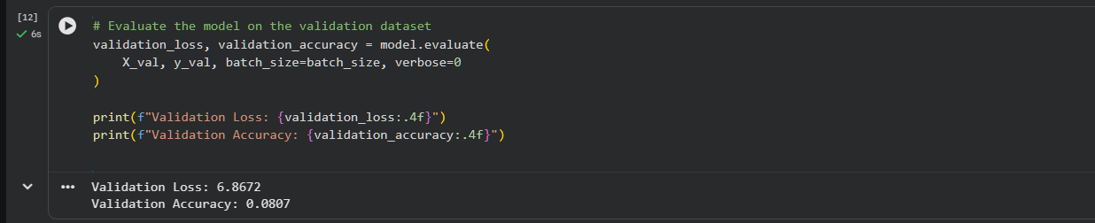

TASK D: DEEP LEARNING EXPERIMENT MANAGEMENT
Perform the following tasks:
- Provide a seed word or sentence as input to the trained model.
- Generate text by repeatedly predicting the next word in the sequence.
- Produce multiple text samples using different seed inputs.
- Compare the generated text for coherence and contextual relevance.
- Document the observations and upload the notebook to GitHub.

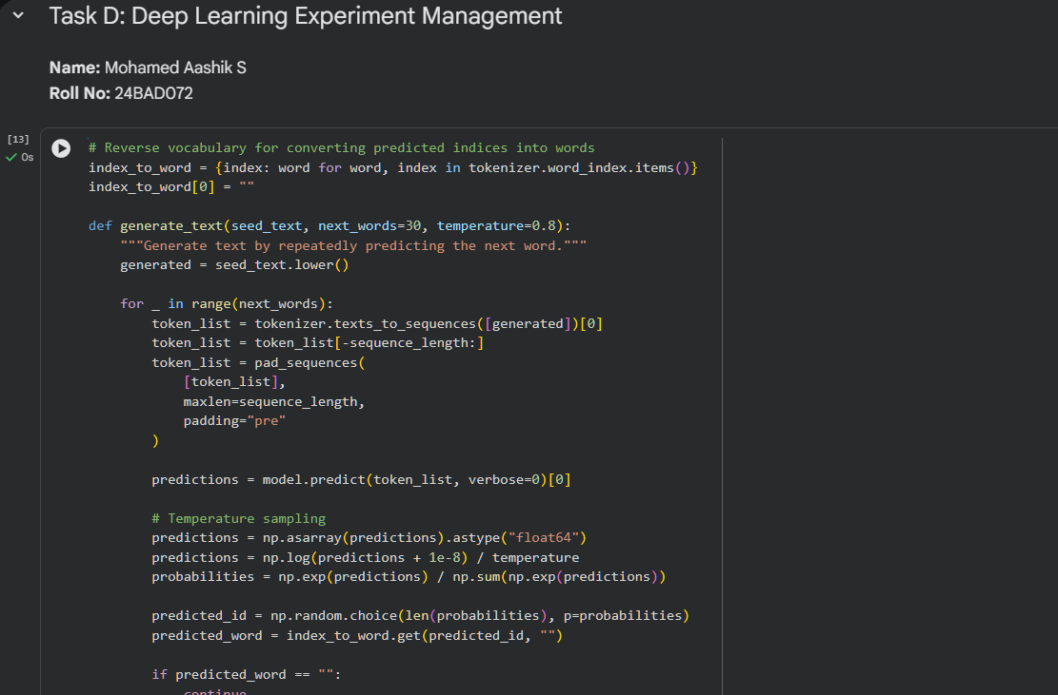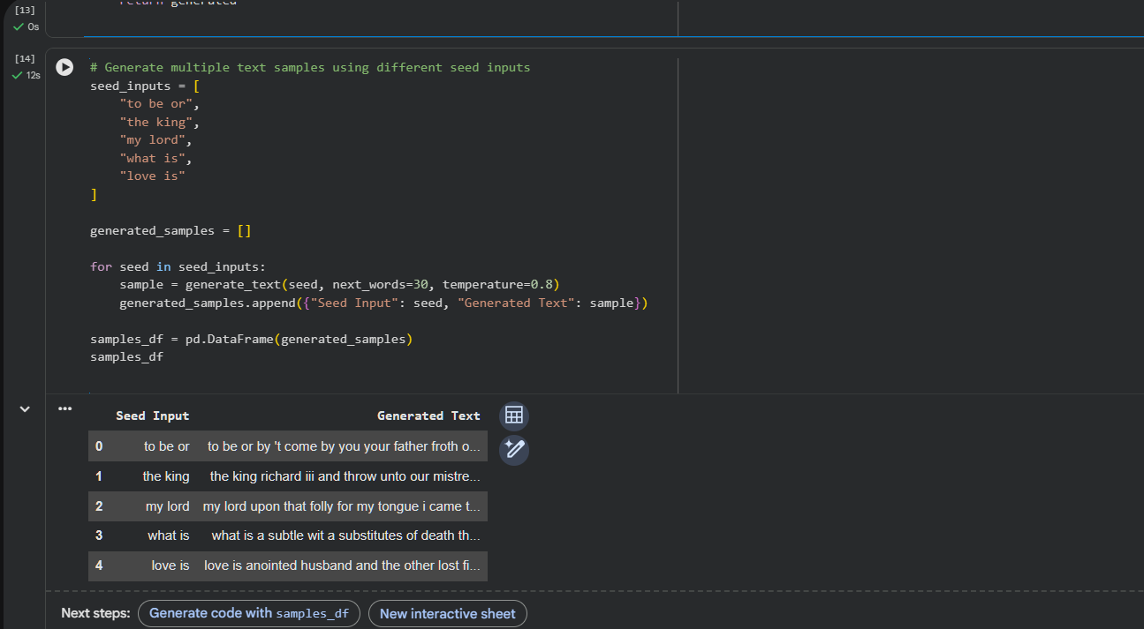
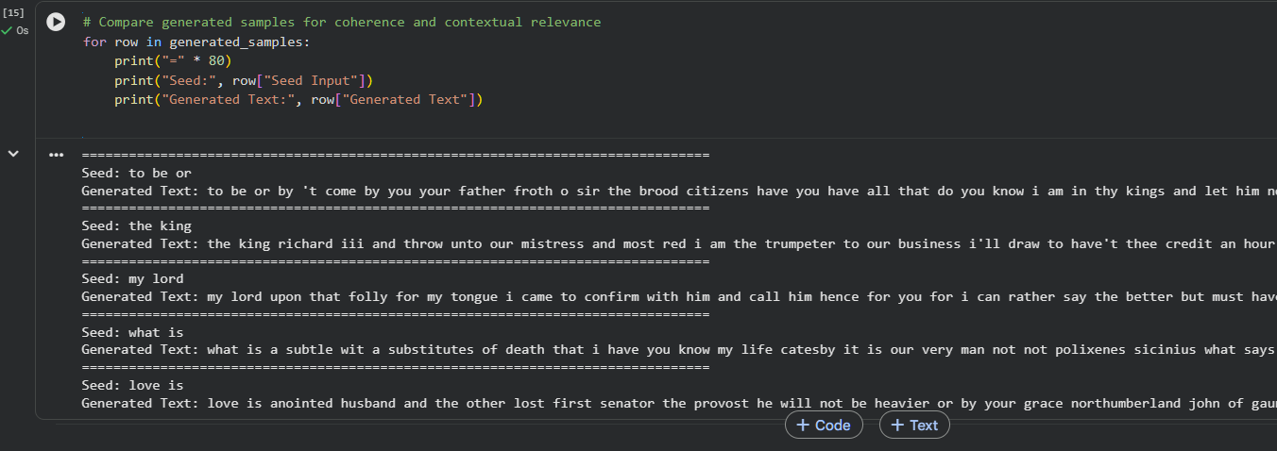

POST-LAB QUESTIONS

- Describe the role of the hidden state in an RNN during sequence processing.

The hidden state stores information about previously processed elements of a sequence. At each time step, it is updated using the current input and the previous hidden state. This allows the RNN to retain contextual information from earlier words. The hidden state helps the model understand dependencies within the text sequence. It is therefore important for predicting the next word based on previous context.

- Discuss the effect of training an RNN model for an insufficient number of epochs.

Training an RNN for too few epochs may prevent the model from learning useful patterns. The model may have low training accuracy and relatively high training loss. Its generated text may contain incorrect words or lack meaningful context. The validation performance may also remain poor because the model is undertrained. Increasing the number of suitable epochs can help the model learn better representations.

- Explain the purpose of padding when preparing text sequences for RNN training.

Padding is used to make sequences of different lengths equal in size. RNN models generally require inputs within a batch to have the same sequence length. Shorter sequences are extended by adding special padding values. This allows multiple sequences to be processed together efficiently during training. Padding therefore helps prepare text data in a suitable format for RNN input.

- Discuss one limitation of a Simple RNN when processing long text sequences.

A major limitation of a Simple RNN is its difficulty in remembering information from very long sequences. During training, gradients can become extremely small as they pass through many time steps. This problem is known as the vanishing gradient problem. As a result, the RNN may lose important information from earlier words in long text. Therefore, Simple RNNs may perform poorly when long-term dependencies are required.

- Discuss the effect of sequence length on the performance of the text generation model.

Sequence length determines how much previous context the RNN receives when predicting the next word. A short sequence may provide insufficient context and produce less coherent text. A longer sequence can provide more contextual information and improve predictions. However, very long sequences can increase computation and make training more difficult. Therefore, an appropriate sequence length should be selected to balance context and performance.

ASSESSMENT
Description | Max Marks | Marks Awarded
Pre Lab Exercise | 5
In Lab Exercise | 10
Post Lab Exercise | 5
Viva | 10
Total | 30
Faculty Signature

